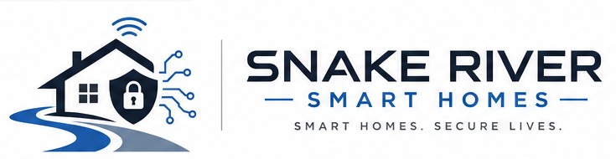 | Door-to-door smart home price sheet  Nicson White | 208-716-6271 | 01nicsonwhite@gmail.com
Make your home feel safer, smarter, and easier to live in.
Free neighborhood consultation for smart cameras, locks, lighting, security, automation, setup, and support in Southeast Idaho.
See what matters  Doorbell, driveway, garage, and entry camera options. | Control the basics  Lights, locks, schedules, and scenes from your phone. | Keep it simple  Clean setup, account organization, and plain-language training.
Popular door-step packages
Final pricing depends on your home, devices, wiring, Wi-Fi, and installation needs. These ranges help homeowners quickly compare starting points.
Front Door Confidence  Video doorbell or smart lock planning, setup, app training.  Common starter: $199-$499+ | Camera Coverage Plan  Driveway, entry, garage, or backyard camera layout and install.  Common starter: $399-$1,499+ | Lighting That Helps  Smart switches, dimmers, schedules, arrival and night scenes.  Common starter: $249-$799+
Security Basics  Sensors, alerts, smart alarm setup, account and notification tuning.  Common starter: $299-$999+ | Automation Bundle  Voice assistant, routines, scenes, and device cleanup.  Common starter: $199-$699+ | Local/Hosted Cameras  Privacy-conscious camera options with local viewing when it fits.  Custom quote
Quick home check  ☐ Front door or side door feels exposed  ☐ Driveway, garage, or package area needs visibility  ☐ Lights/locks are annoying at night or when leaving  ☐ Wi-Fi or apps are messy and need cleanup  ☐ You want privacy-conscious recommendations | Door offer  Free 10-minute smart home walk-through  I can look at the doors, driveway, garage, Wi-Fi location, and daily routines, then give you a best option, budget option, and phased option.  No pressure. No generic bundle. Just a practical plan.
Serving  Idaho Falls, Rexburg, Ammon, Rigby, Shelley, and nearby Southeast Idaho cities. | Best fit for  Homeowners who want safer entries, cleaner camera coverage, easier routines, or smart devices that finally work together. | Next step  Text or call 208-716-6271 to schedule your free consultation with Nicson White.
Snake River Smart Homes | Smart Homes. Secure Lives. | Free consultations

